Template for Manager Email Communication to New Hire

Subject: Welcome to the Team!

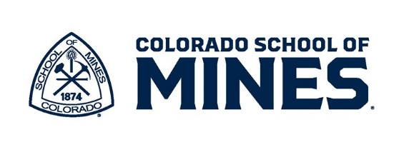
Hello (Employee’s Name),
I want to officially welcome you to the team! We are thrilled to have you join us and look forward to the skills, experience, and fresh perspective you will bring to your new role.
Starting a new job is an important transition, and I want to ensure you feel supported and prepared as you get started. This email includes key information to help you navigate your first few days and introduces some of the resources and people who will support your success.
On your first day, I plan to meet you on (Date) at (Time) in (Location). The best place to park is lot (add lot information from campus map). I have attached a campus map to help you find your way. (Add the destination code from the campus map, e.g. Guggenheim Hall - F6.)
There are several dining options available on campus. Or visit downtown Golden for additional places to eat. (This would be a good place to let the new hire know if you plan to take them out to lunch on their first day.)
Please don’t hesitate to reach out with any questions - I am here to support you every step of the way.
Best regards,
(Manager’s Name and Phone Number)

Mines Administrative Processing Services (MAPS)
If you haven’t already, you will soon receive an email from our MAPS office with important employment tasks to complete before and on your first day. The MAPS office handles all employment and payroll processes for the university and is a separate department than Human Resources.

Parking Information
For those working on campus parking permits are available for purchase either in person, by phone, or online. You may visit Parking Services on your first day, or, within 48 hours of claiming your Mines account you and purchase a permit online. To purchase via phone, contact Parking Services at 303.273.3100.
Parking Services is located in McNeil Hall, 1400 Maple Street, Room 127, Golden, CO 80401. If you visit in person, please bring your campus ID number, sent via email by MAPS, and vehicle license plate number. You can also view our parking map to find available lots.

BlasterCard and Building Access
Every employee is required to get a BlasterCard (your campus ID), which serves as both your building/office access as well as your key to using campus printers. Please visit the Student Life Services Office (E140), located on the first floor of the Ben Parker Student Center, to get your BlasterCard during your first week of employment.

New Employee Orientation (NEO)
All employees are required to attend NEO. The orientation is held online every two weeks and may not occur until your second week of employment. NEO runs from 9am to noon and logging into the Mines network is not required to participate. Human Resources will send NEO invitations to both the personal email listed in your application and your Mines’ email address (if the account has been created). If you are scheduled to attend NEO on your first day, please check with your manager to clarify expectations for the remainder of the day.
Your scheduled NEO date is: ____________________________________ (check the NEO schedule to include date)

Benefits Elections
Within your first week of employment, our Benefits team will contact you via email with instructions for selecting your benefits. Please note that you have 31 days from your start date to make your elections. For questions reach out to Benefits@mines.edu.

